# Google Cloud Platform

Before starting to use any Google Service API, you need to create a project in [Google Developer Console](https://console.cloud.google.com/), this is where you can manage your Google Service, create API to link with your account and track your service usage.

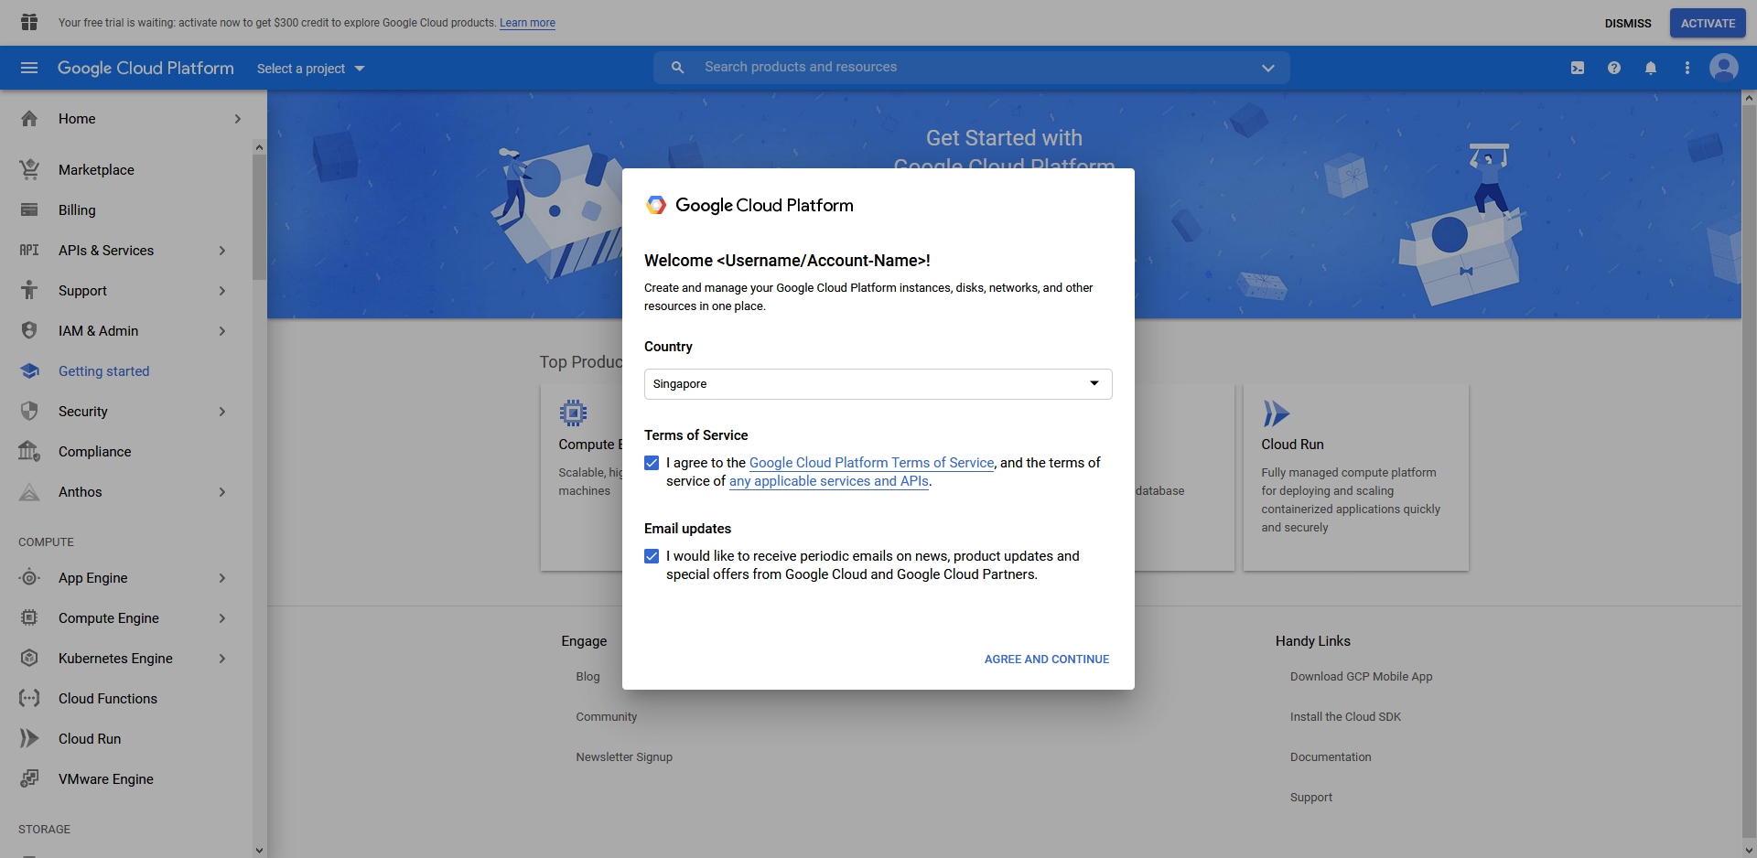

On first usage, you will be asked to agree to Google’s Terms of Service (TOS), it is not required to check the box for email updates.

## Create a new project

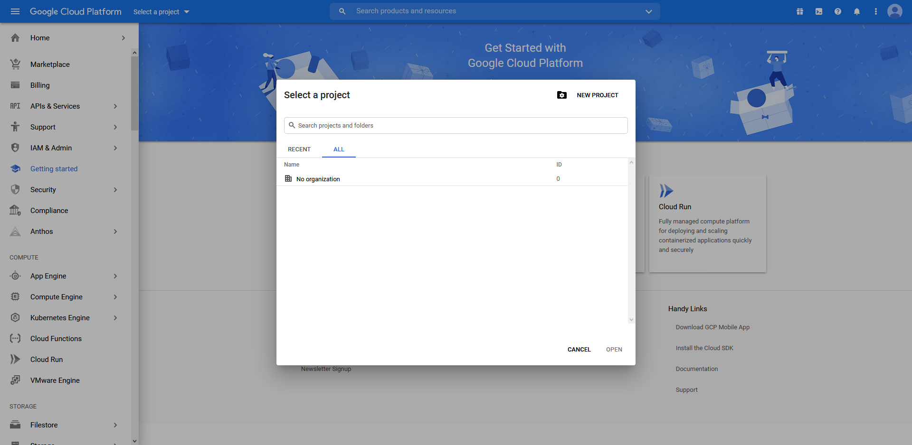

Go to “Select a project”, and click on the “New Project” button to create a new project.

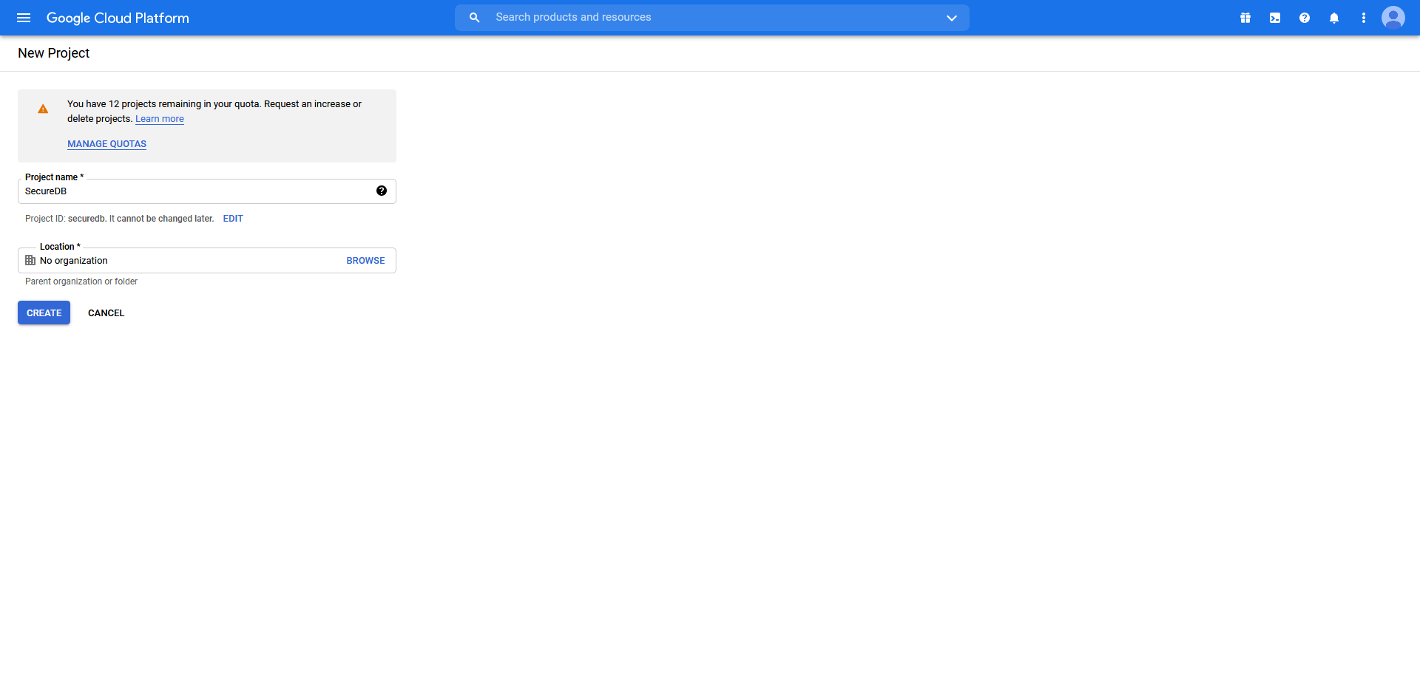

Give the project a name, organisation is optional.

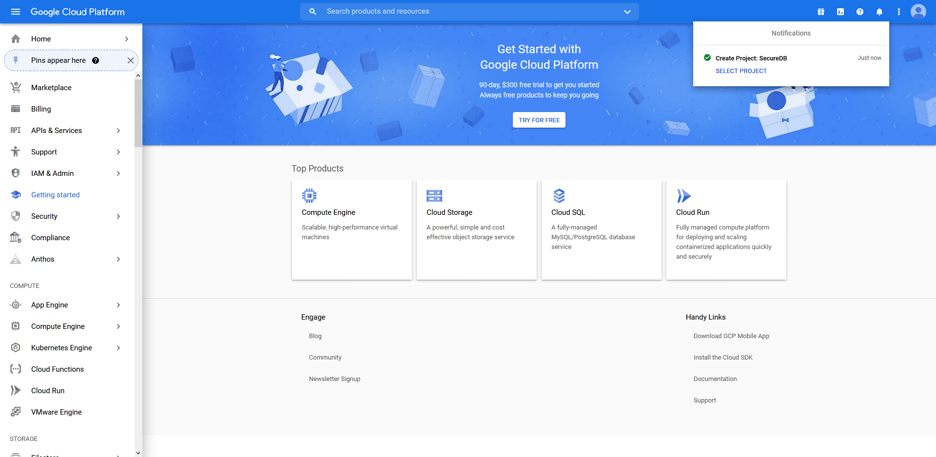

After creating the project, you will be redirected to the homepage with a notifications popup.

## Enable Service API

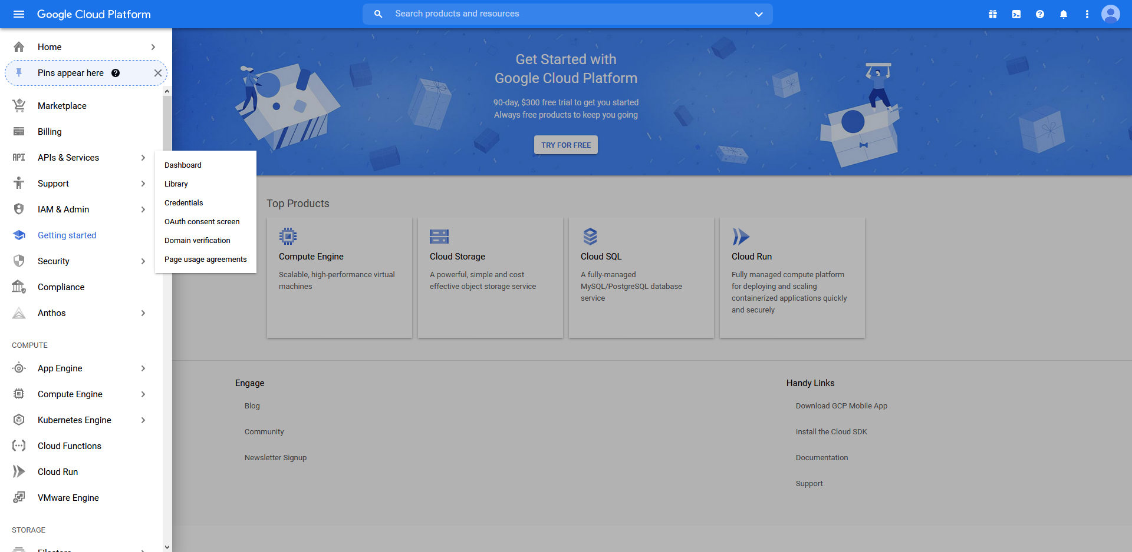

On the menu at the left, hover over “APIs & Services” and click on “Library”. (If the menu is not shown for you, click on the hamburger menu on the top left corner to display the list of items)

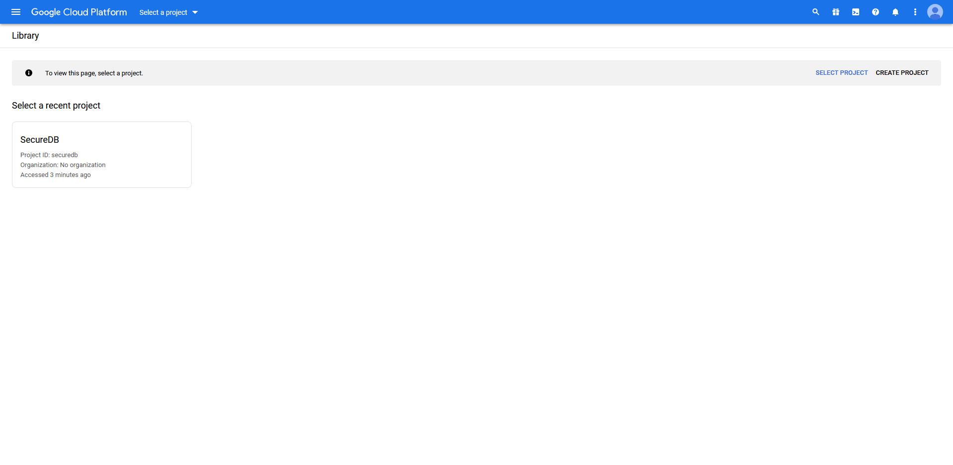

If you see this page, select the project that you have just created.

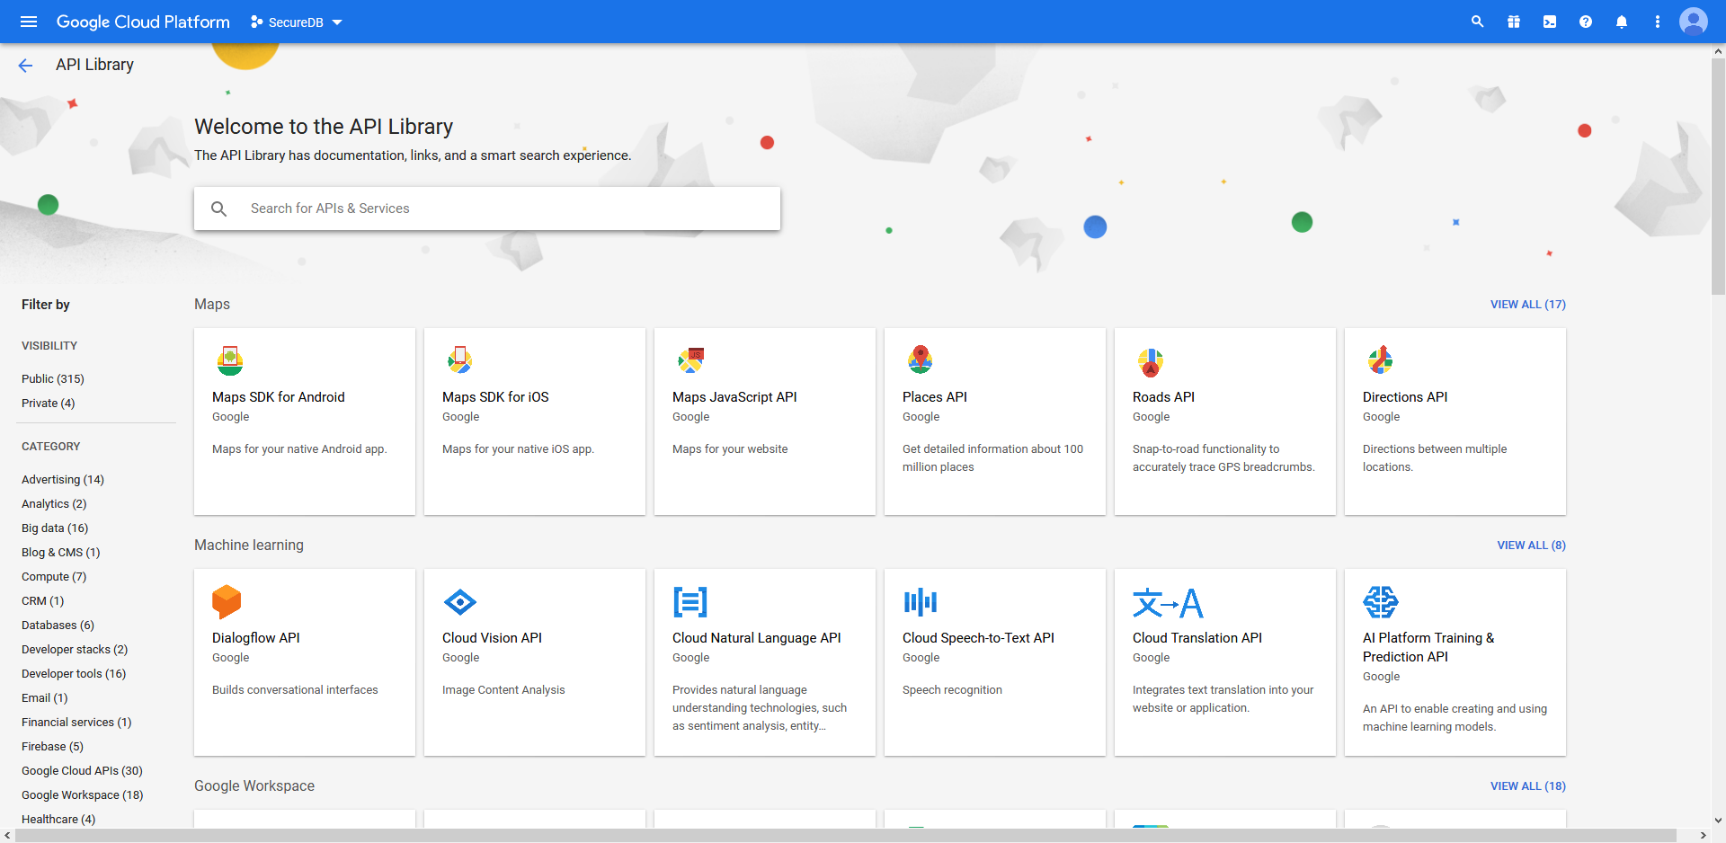

You will be redirected to this screen.

In the search bar, search for “Google Drive API”.

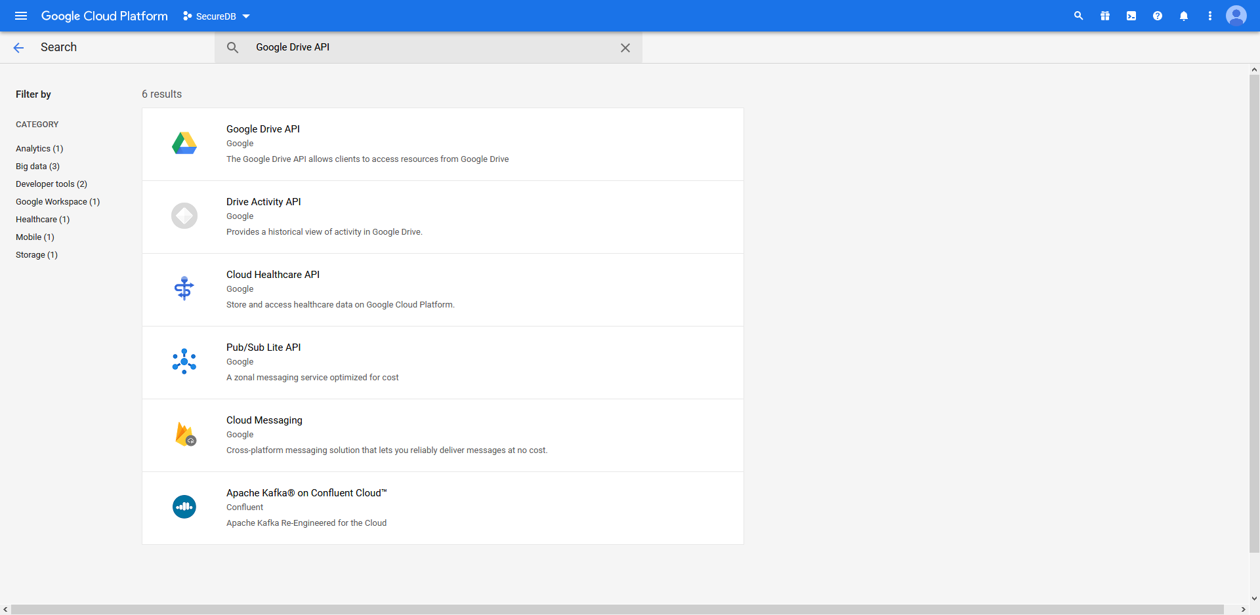

Click on the 1st result to select the API

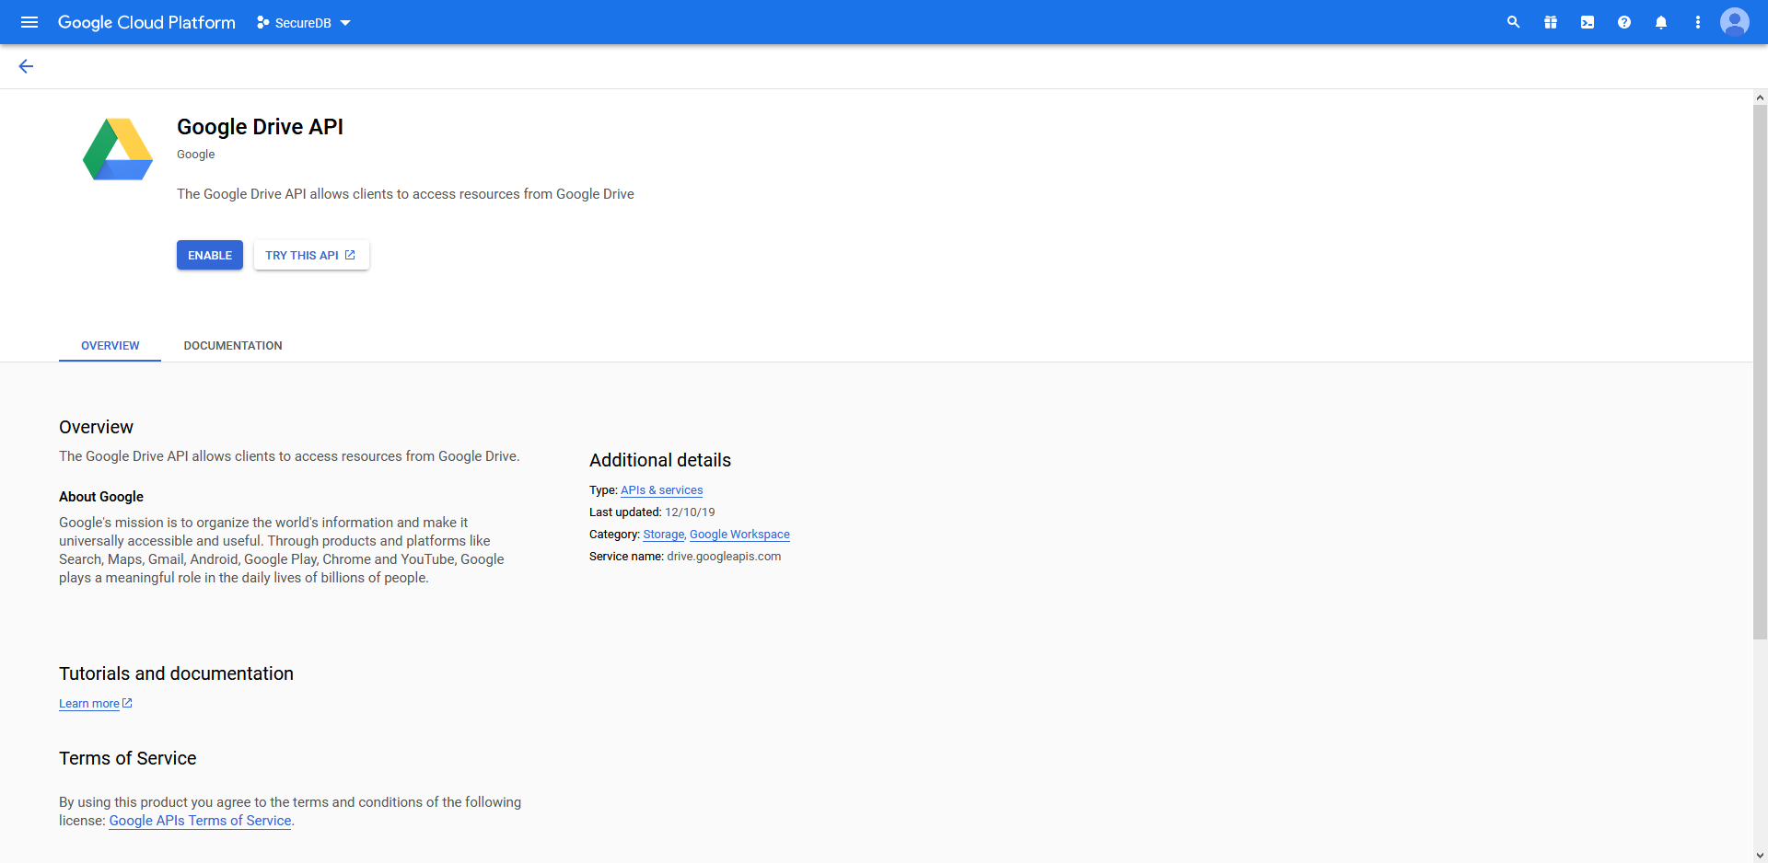

Then click on “Enable” to enable the API

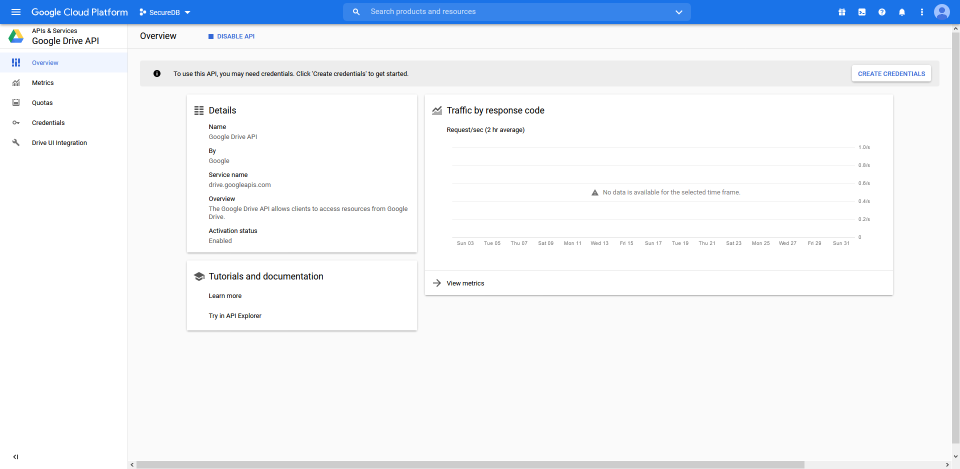

After enabling, you will be redirected to this screen.

Navigate to the “Credentials” option on the left.

## Create Client ID credential

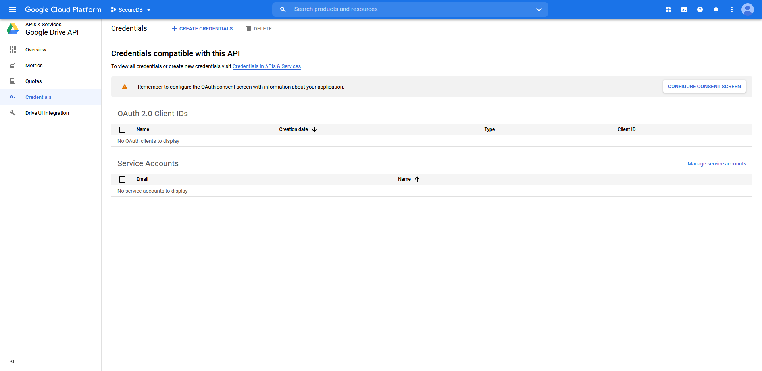

Upon clicking on the “Credentials” option, you will be greeted with this screen.

Select the “Create Credentials” button on the top

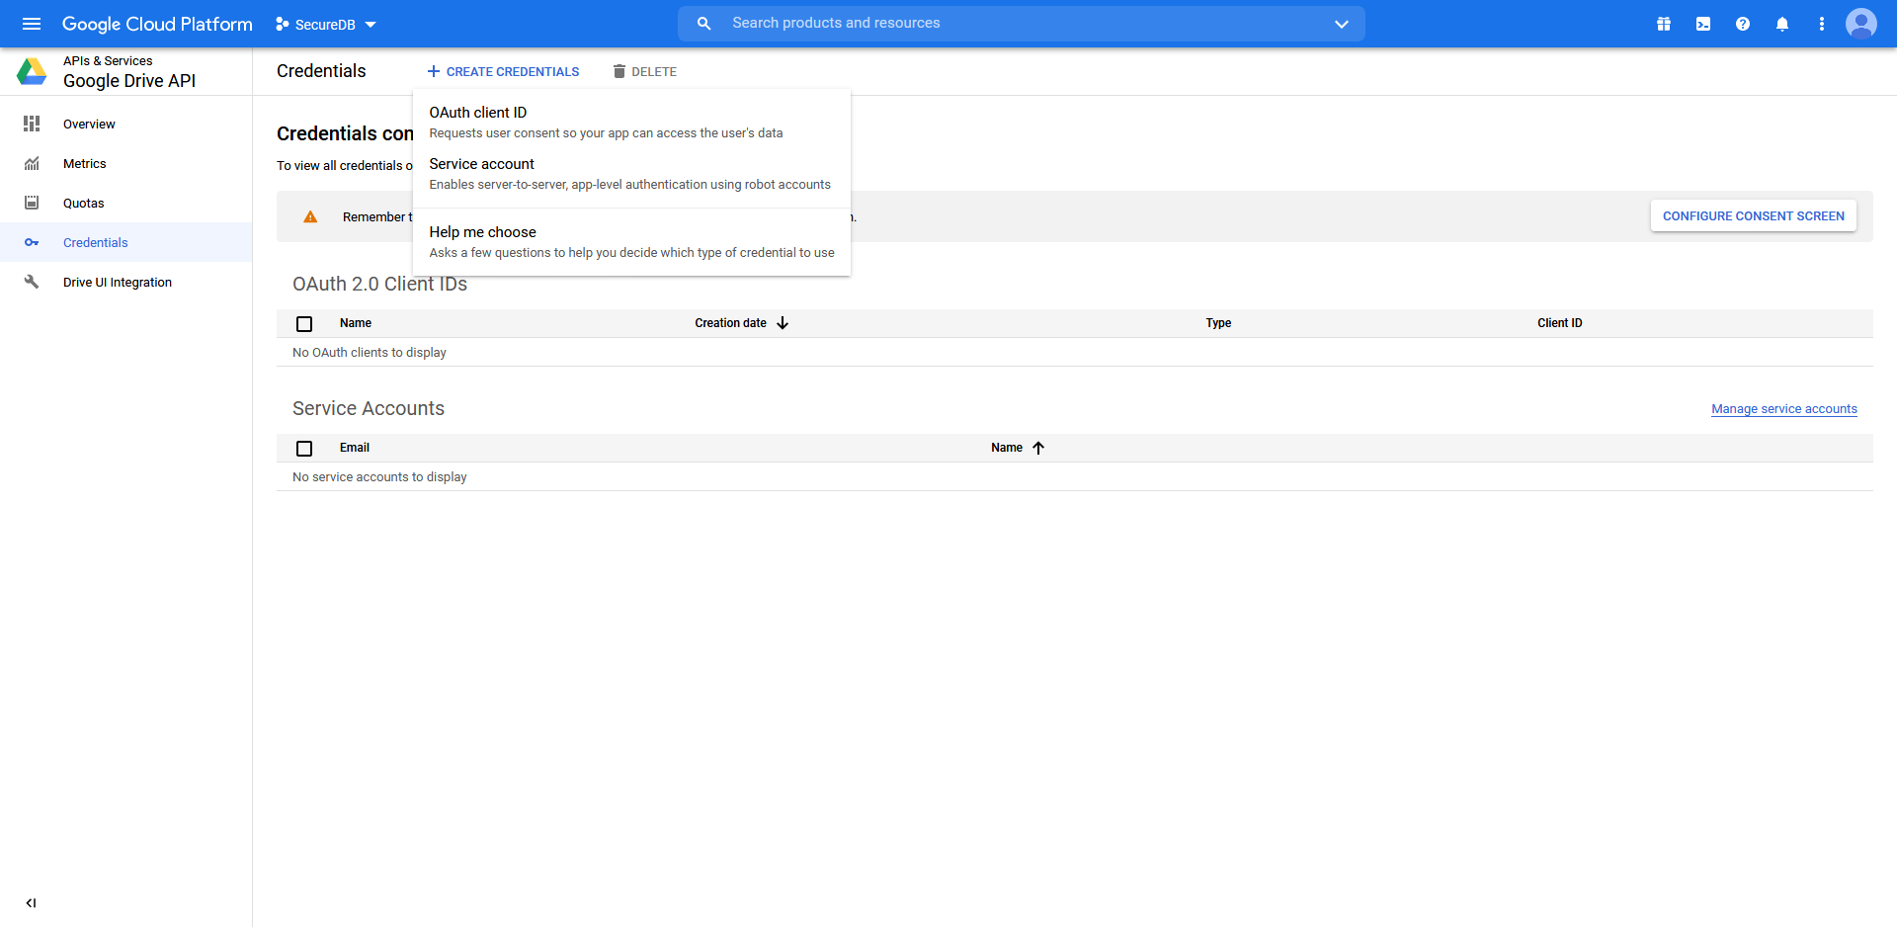

Then choose the “OAuth client ID” option

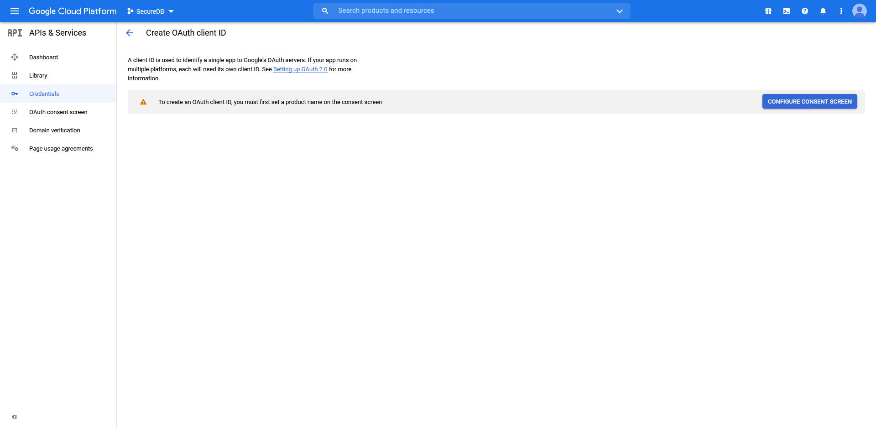

Sometimes, you might be greeted with this screen, you will need to configure the OAuth consent screen, by clicking on “Configure Consent Screen”

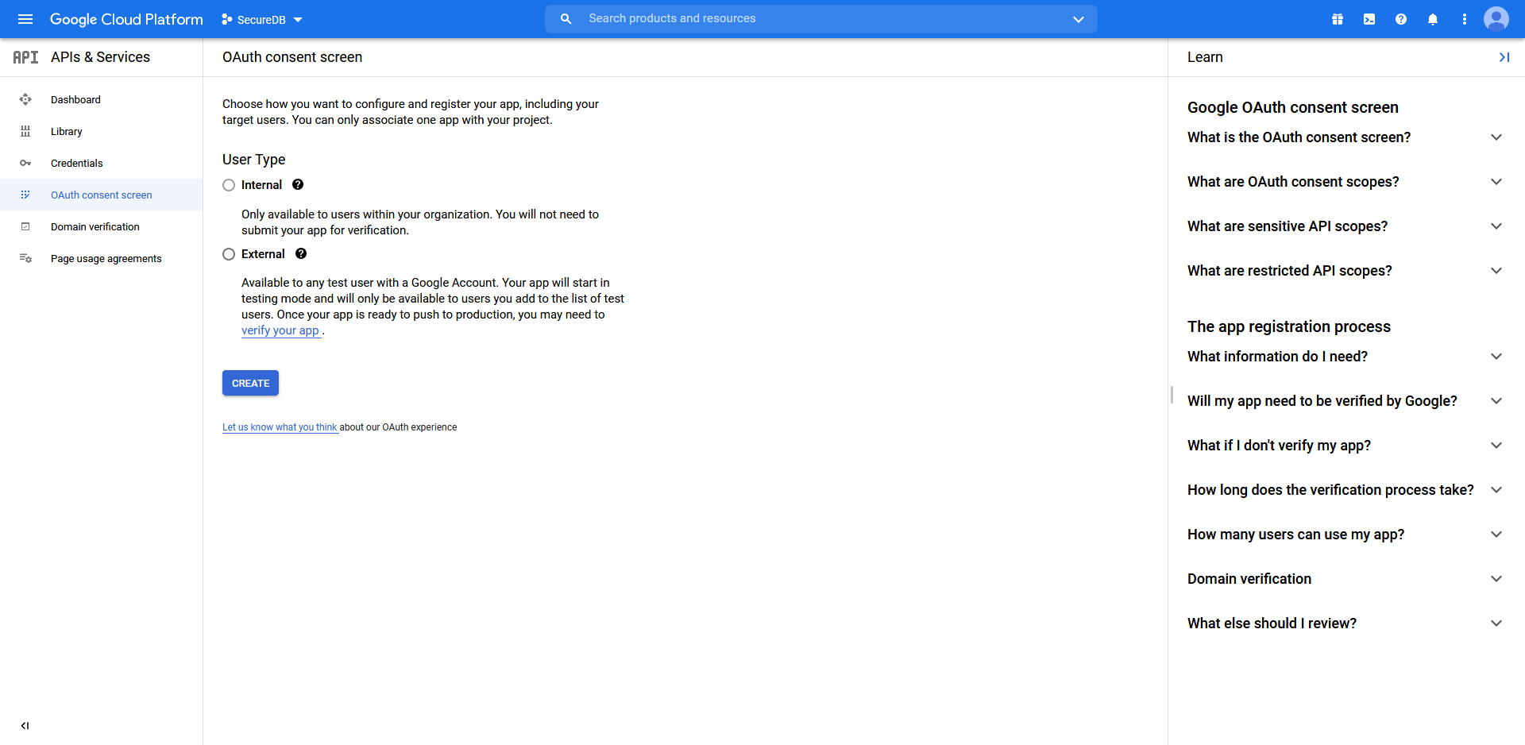

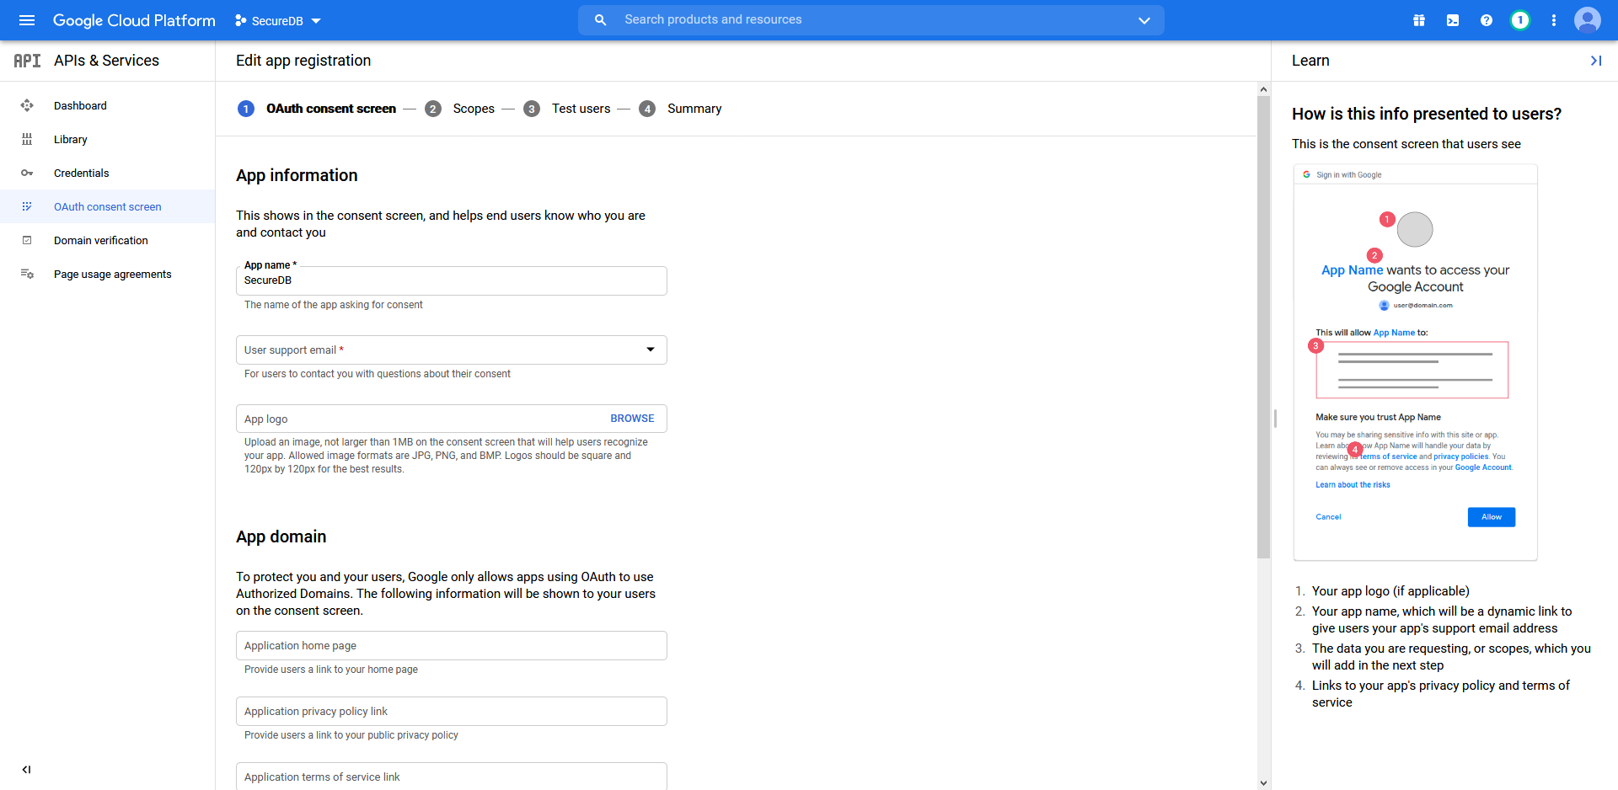

Fill up which every information that is relevant and required for you. Then scroll to the bottom and click on the “Save and Continue” button.

For the rest of the setup for “Scopes” and “Test Users” fill up as per your needs.

After finishing, go to OAuth consent screen again and for publishing status, set it to deploy.

After completing that, go back and click on “Credentials” >> “Create Credentials” >> “Create OAuth client ID” again.

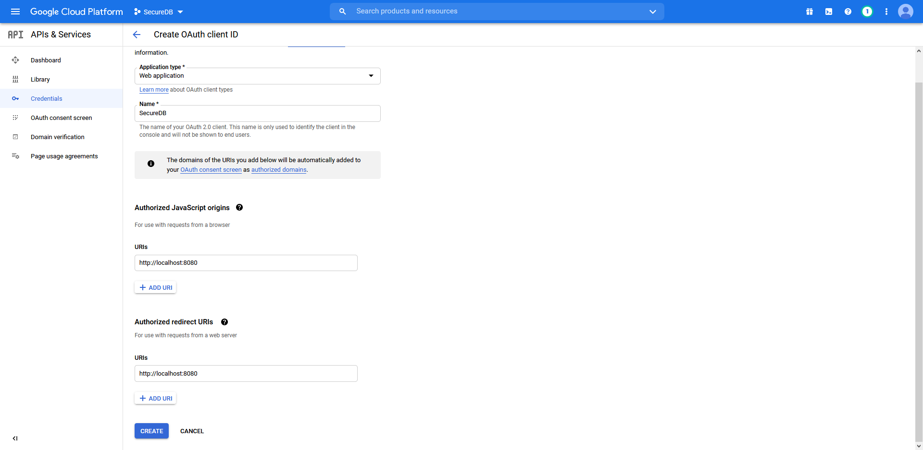

For application type, select “Web Application” and fill up the URIs as “http://localhost:8080” and “http://localhost:8080/”, and then click on done.

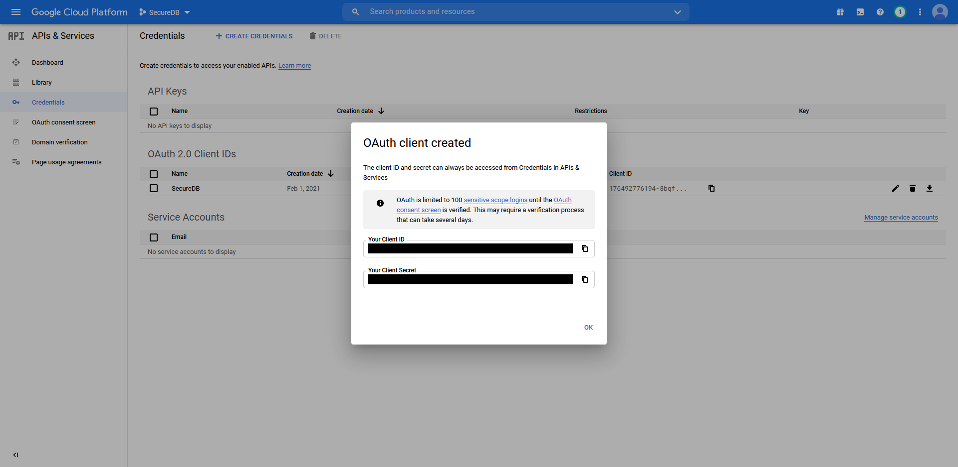

After creating the OAuth client ID, copy down the “Client ID” and “Client Secret”, these will be used in the onboarding later.

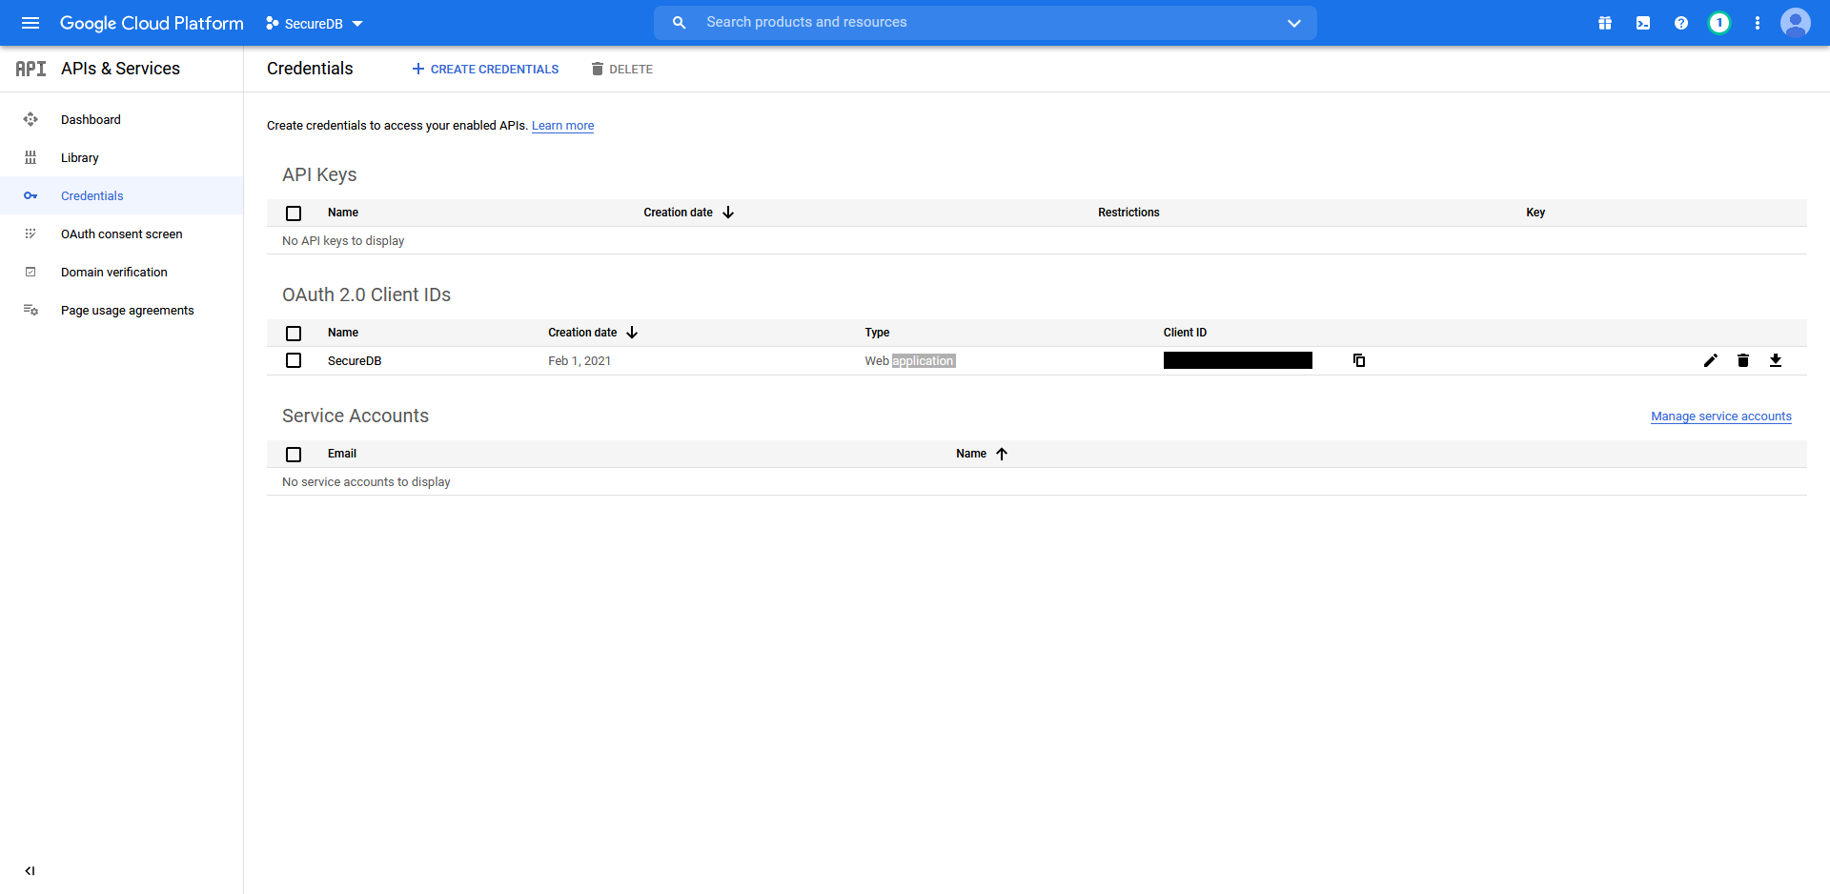

Then click on the download button to download the “Client_Secrets_<Client_ID_extension>.json” file, this would be used later on for the onboarding as well.